**“Experiment 1.2”**

Student Name: **SUMIT KUMAR** UID: **20BCS8226**

Branch: **CSE** Section/Group: **808-A**

Semester: **5** Date of Performance: **11-08-22**

Subject Name: **PBLJ Lab** Subject Code: **20CSP-321**

**AIM:**

Design and implement a simple inventory control system for a small video rental store.

**Minimum Hardware Requirements:**

* 2 GHz CPU or 1 virtual CPU in virtualized environments.
* 1 GB of RAM.
* 4 GB of storage.

**Minimum Software Requirements:**

|  |  |
| --- | --- |
| **Software** | **Version** |
| * OS | * Mac OS 10.15, HP-UX 11i V3, AIX 7.2, Windows Server 2019, Windows 10, Solaris 11.3, Red Hat Enterprise Linux 8.1, Ubuntu Server 20.04 |
| * JDK | * JDK 1.8.0, JDK 11, Ellipse IDE, Net, NetBeans 8.2 |

**Source Code:**

// SUMIT KUMAR

// UID: 20BCS8226

// Save: VideoLauncher

**package** practice2;

**import** java.util.Scanner;

**public** **class** VideoLauncher {

**public** **static** **void** main(String[] args) {

Scanner input=**new** Scanner(System.***in***);

**int** choice;

VideoStore videoStore=**new** VideoStore();

**do** {

System.***out***.println("MAIN MENU \n=========");

System.***out***.println("1. Add Videos:");

System.***out***.println("2. Check Out Video:");

System.***out***.println("3. Return Video:");

System.***out***.println("4. Receive Rating:");

System.***out***.println("5. List Inventory:");

System.***out***.println("6. Exit:");

System.***out***.print("Enter your choice(1..6): ");

choice=input.nextInt();

**switch** (choice) {

**case** 1:

System.***out***.println("Enter the name of the video you want to add: ");

videoStore.addVideo(input.next());

**break**;

**case** 2:

System.***out***.print("Enter the name of the video you want to check out: ");

videoStore.doCheckout(input.next());

**break**;

**case** 3:

System.***out***.print("Enter the name of the video you want to Return:");

videoStore.doReturn(input.next());;

**break**;

**case** 4:

System.***out***.println("Enter the name of the video you want to Rate: ");

videoStore.receiveRating(input.next(), input.nextInt());

**break**;

**case** 5:

videoStore.listInventory();

**break**;

**case** 6:

System.***err***.println("Enter ...!! Thanks for using the application");

System.*exit*(1);

**break**;

}

}**while**(!(choice==6));

input.close();

}

}

// Save: VideoStore

**package** practice2;

**public** **class** VideoStore {

Video[] store;

**public** VideoStore() {

// **TODO** Auto-generated constructor stub

store=**new** Video[5];

}

**public** **void** addVideo(String name)

{

store[0]=**new** Video(name);

System.***err***.println("Video "+'"'+store[0].getName()+'"'+" added successfully");

}

**public** **void** doCheckout(String name)

{

**if**(store[0].videoName.equals(name))

{

store[0].doCheckout();

}

}

**public** **void** doReturn(String name)

{

**if**(store[0].videoName.equals(name))

{

store[0].doReturn();

}

}

**public** **void** receiveRating(String name, **int** rating) {

**if**(store[0].videoName.equals(name))

{

store[0].receiveRating(rating);

}

System.***err***.println("Rating "+'"'+store[0].getRating()+'"'+" has been mapped to the Video ''"+store[0].getName()+'"');

}

**public** **void** listInventory() {

System.***out***.println("------------------------------------------");

System.***out***.println("Video Name | Checkout Status | Rating");

System.***out***.println(store[0].getName()+"|" +store[0].getCheckout()+ "|"+ store[0].getRating());

System.***out***.println("------------------------------------------");

}

}

// Save: Video

**package** practice2;

**public** **class** Video {

String videoName;

**boolean** checkout;

**int** rating;

**public** Video() {

}

**public** Video(String name)

{

videoName=name;

}

**public** String getName()

{

**return** videoName;

}

**public** **void** doCheckout()

{

System.***err***.println("Video "+'"'+ getName()+'"' +" checked out successfully.");

}

**public** **void** doReturn()

{

checkout=**true**;

System.***err***.println("Video "+'"'+ getName()+'"' +" returned successfully.");

}

**public** **void** receiveRating(**int** rating)

{

**this**.rating=rating;

}

**public** **int** getRating()

{

**return** rating;

}

**public** **boolean** getCheckout()

{

**return** checkout;

}

}

**Output:**

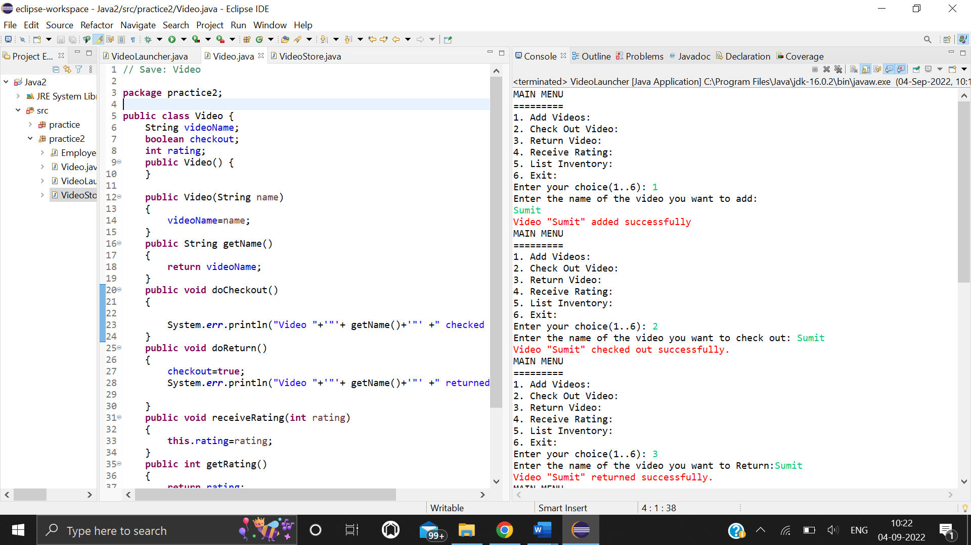

**Screenshot of executing choices 1 to 3**

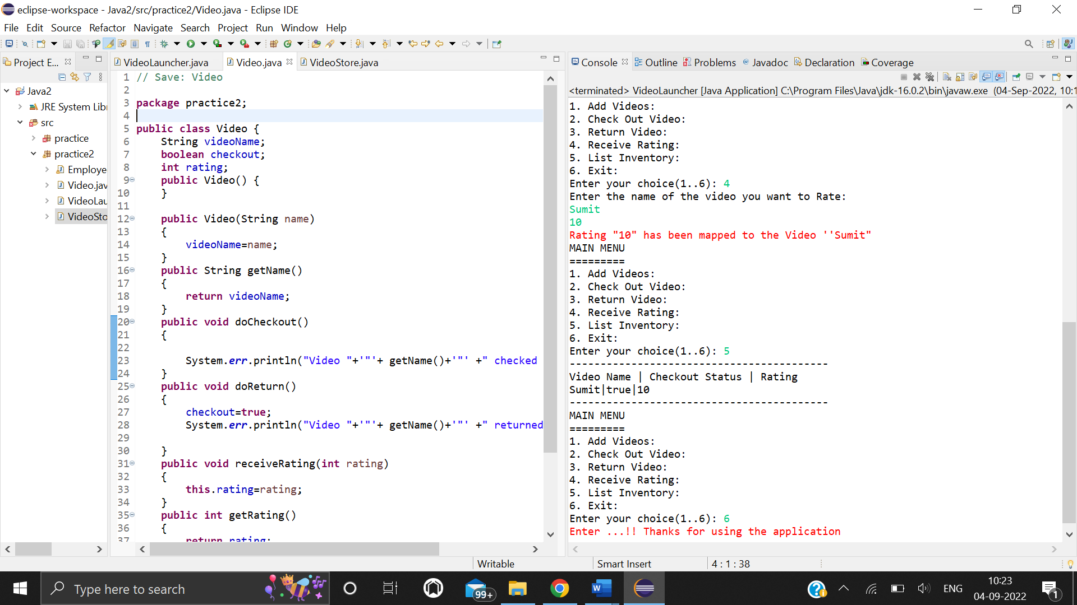

**Screenshot of executing choices 4 to 6**

**Learning outcomes:**

* Learn about getter and setter method.
* Learn about factory method.
* Learn to make code more efficient and maintainable by using Code refactoring.
* Learn how to implement object-oriented designs with Java.
* Learn how to use exception handling in Java applications.